**Maxwell Okoth**

+254774909759|maxwellokoth18@gmail.com|4084-4(Kisumu,Kenya, 254)

Online Portfolio/Professional Website

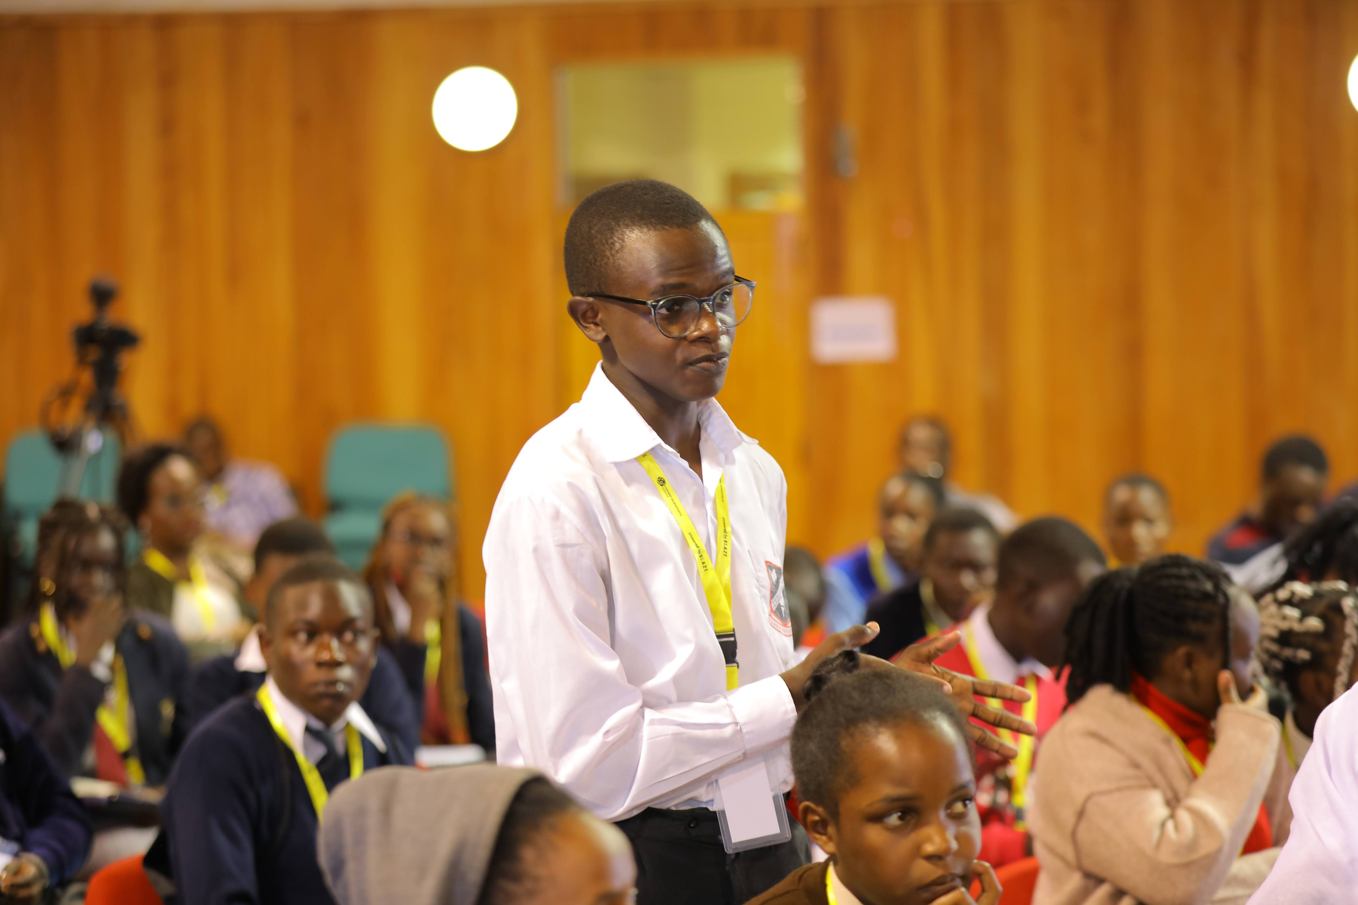

**PROFESSIONAL SUMMARY**

Web developer with two years of experience seeking a full-time development position with a growing, fast-paced software startup.*

**SKILLS**

**Expert: Front_end development**, UI/UX, HTML 5, CSS, JAVA SCRIPT,DJANGO,REACT

**Advanced: C, C++, C#**, PYTHON

**Intermediate: ANDROID DEVELOPMENT**

**EXPERIENCE**

***Title, Company Name Start Date - End Date***

* (Action verb) + what you did (more detail) + reason, outcome or quantified results
* (Action verb) + what you did (more detail) + reason, outcome or quantified results
* (Action verb) + what you did (more detail) + reason, outcome or quantified results
* (Action verb) + what you did (more detail) + reason, outcome or quantified results

***Title, Company Name Start Date - End Date***

* (Action verb) + what you did (more detail) + reason, outcome or quantified results
* (Action verb) + what you did (more detail) + reason, outcome or quantified results
* (Action verb) + what you did (more detail) + reason, outcome or quantified results
* (Action verb) + what you did (more detail) + reason, outcome or quantified results

***Title, Company Name Start Date - End Date***

* (Action verb) + what you did (more detail) + reason, outcome or quantified results
* (Action verb) + what you did (more detail) + reason, outcome or quantified results
* (Action verb) + what you did (more detail) + reason, outcome or quantified results
* (Action verb) + what you did (more detail) + reason, outcome or quantified results

**EDUCATION**

***Degree Type, Major (if applicable) Month/Year of Completion***

Institution Name

**AWARDS/RECOGNITIONS/VOLUNTEER WORK - (OPTIONAL)**

* Award, recognition or volunteer work Date
* Award, recognition or volunteer work Date
* Award, recognition or volunteer work Date